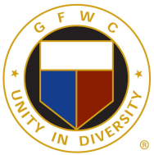
Editor: Jonnah Hetzel gfwcohiobuckeye@gmail.com
Assistant Editor: Marjean Sizemore sizemore172@comcast.net
Circulation Manager: Barbara Savarin barbara.savarin@gmail.com
Proofreaders: Rose Logston and Corky Nosek

The Buckeye Magazine is issued quarterly at the direction of the GFWC/Ohio Federation of Women's Clubs Board of Directors. It is distributed to each per-capita-dues-paying member of the Federation and to each Direct Member. A copy is provided to the President of each club in GFWC/Ohio Federation. The Buckeye Magazine mailing list is compiled from the names, addresses, and emails supplied to the GFWC/Ohio Federation of Women's Clubs Treasurer by club treasurers.

Members should report name and/or address, and/or email changes immediately to their club treasurer AND the GFWC/Ohio Federation of Women's Clubs Treasurer. Please include your club and district. If you know you’re going to move, be sure to let GFWC/Ohio Federation of Women's Clubs Treasurer know before you move, so you won’t miss any issues. This can be done by sending your email address to Jonnah Hetzel at jfhetzel@gmail.com , Deidra Devore at fruitloop119@yahoo.com, and gfwcohiobuckeye@gmail.com.

Articles and photographs in The Buckeye Magazine focus on club news submitted by individual clubs as well as GFWC/Ohio Federation of Women's Clubs programs and projects. In addition, pertinent GFWC information is included for club and member use. To ensure accuracy and quality the preferred method for submission is by electronic means. All articles and photographs become the property of The Buckeye Magazine and will not be returned.

Material submitted to the Editor for publication should be timely and of general interest. The date of publication may be as long as four weeks after the deadline dates printed below. Articles and photographs may be emailed to the Editor at any time. Quarterly issues are usually distributed in the spring (Call to Convention issue), summer, fall and winter.
Deadlines for 2022-2023

• 2022 Fall Issue: Septmember 15 2022
• 2022 Winter Issue: November 14 , 2022
• 2023 Spring Issue: January 23 , 2023
• 2022 Summer Issue: May 15, 2023

The Editor is glad to work with club publicity or public relations chairmen or reporters to prepare material for The Buckeye Magazine.
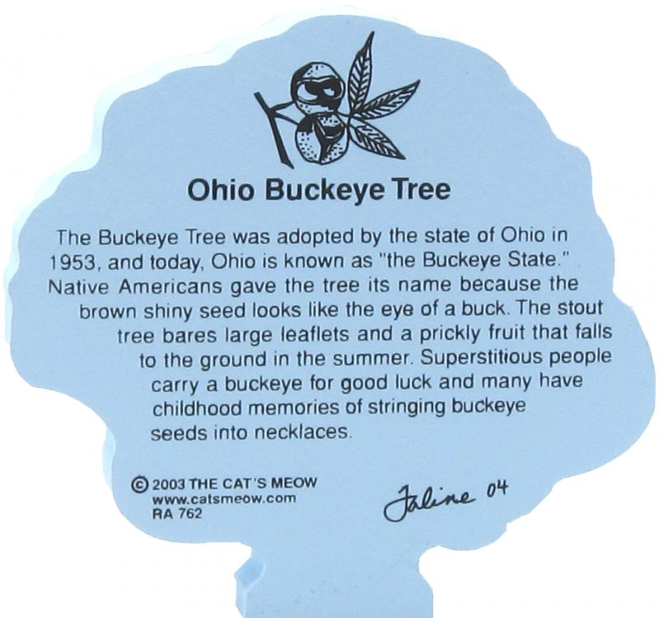

If you have questions, please email or call: Jonnah Hetzel, Editor.
1228 E. Walnut St.
Westerville, OH 43081
330-770-8374 jfhetzel@gmail.com

Send articles and opt-in to email only to: gfwcohiobuckeye@gmail.com

