**JUNIORETTE AGREEMENT**

I, _______________________________ pledge to abide by the following agreement while I am attending the

_______________________________________ (meeting/event)

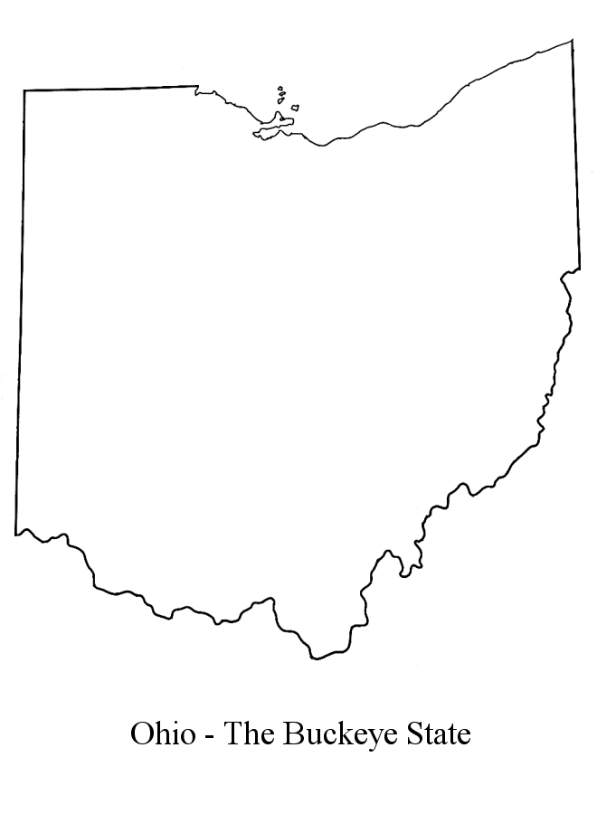

_______________________________________ (place)

GFWC Ohio

Juniorettes

_______________________________________ (date)



* I will not leave the hotel premises without a chaperone or advisor.
* I will abstain from the use of illegal drugs and alcohol.
* I will check in with my chaperone at an agreed upon time.
* I will behave in a manner that will reflect a positive image of the Juniorettes.
* I will attend the meetings and share the information with my club members.
* I will follow any rules set by my advisor.

I understand that failure to abide by this agreement can result in my having to leave the meeting immediately and that my parents will be called and responsible for returning me to my home. I further understand that there might be other disciplinary action taken.

Signed ______________________________________________

Club ________________________________________________

Date ____________________Cell number__________________

Parent**_______________________________________________**

Home Phone________________________Cell______________________

Advisor/Chaperone__________________________Cell________________

**PERMISSION/MEDICAL AUTHORIZATION/RELEASE**

**I, __________________________________________________, as parent/legal guardian of**

**___________________________________________________, hereby give my permission**

**for my daughter’s attendance and participation at the before mentioned meeting event. In the event of illness or injury, I authorize to give consent for any necessary emergency medical treatment on behalf of my daughter. I understand that the GFWC or OFWC, its members or chaperones are not liable for expenses incurred, including hospital or emergency transportation, for the treatment of any such injury or illness and that I am liable for all such expenses. In the event of a medical emergency, I further authorize**

**________________________________________ to provide the medical services provider**

**with insurance information. A copy of my child’s insurance card is attached for that purpose, as well as a list of any known allergies and any medications my child may be taking at this time. My emergency contact phone numbers are home_______________**

**and cell number_________________________.**

**As consideration for allowing my daughter to attend and participate in the above mentioned meeting/event, I release and forever discharge the GFWC, the OFWC, its members and chaperones from any and all claims, actions, or liability which I or my daughter have or may have against the GFWC, the OFWC, it members and chaperones concerning or in any manner connected with or arising from my daughter’s attendance and participation in the above mentioned event, including any and all acts of negligence occasioned by the GFWC, the OFWC, its members and chaperones.**

**______________________, 20_____.**

**_________________________________________________**

**DATE Individually, and as Parent/Legal Guardian of**

**_________________________________________________**

**Juniorette’s Name**

**Sworn and subscribed before me in the State of Ohio, County of ___________________**

**By _____________________________________________, who is personally known to me**

**or produced the following identification_________________________________________**

**Witness____________________________________________________________________**